**Mathematical Model:**

1. **Problem Description**

Lets U be the Document Verification & Authentication System which is used in any document authentication (passport, pan card, driving license) to authenticate the document for its owner. Such that

U = {I, A, B, T, P, S}

Where, I represent set of input image; = {I1}

A represents First Name; = {A1, A2, A3...............AN}

B represents Second Name; = {B1, B2, B3...............BN}

T represents Third Name; = {T1, T2, T3...............TN}

P represents passport number; = {P1, P2, P3.........PN}

S represents Surname; = {S1, S2, S3.........SN}

RW represents Row; = {RW1, RW2, RW3……..RWN}

C represents Column; = {C1, C2, C3……..CN}

O represents Set of Output Image cards; = {O1, O2, O3.......ON}

F is a set of functions;

F = {FCR, FCC, FCS, FS, FR, FN, FM}

FCR = Function to Compute Row by First Name

FCR (A) = RW;

FCC = Function to Compute Column by Second Name

FCC (B) = C;

FS = Function to Store Average value of R, G, B

FS (R, G, B) = avg;

FCS = Function to Compute sum of Third Name, Surname, Passport Number

FCS (T, S, P) = sum;

FN = Function to Compute Number of Pixels

FN (sum, avg) = N; (sum % avg)

FR = Function to Compute value of RColumn by adding number of pixels, columns and 1.

FR (C, N) = RColumn;

FM = Function to Read MAX of R, G, B at row and RColumn

FM (R, G, B, RW, RColumn) = Max Value;

1. FCR :
2. FCC:
3. FS:
4. FCS:

1. FN:
2. FR:
3. FM:

Venn diagram:

1. FS = Store average value

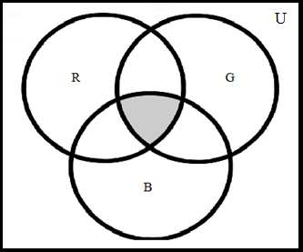

Where,

R= Red Values

G = Green Values

B = Blue Values

R ∩ G ∩ B = {Average Value to store}

1. FN = Calculate number of pixels.

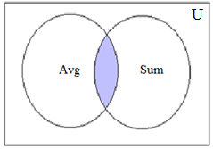

Where,

Avg = Average Values

Sum = Computed Sum Values

Avg ∩ Sum = {Number of Pixels}